Technology Stack (Architecture & Stack) — AI FAQ Assistant
Backend-Only RESTful API — No Frontend / UI Layer
Date | 26 September 2026
Team ID | 6ab4aef20fc666a751b4634f
Project Name | AI FAQ Assistant
Maximum Marks | 4 Marks
Project Type: Backend-only RESTful API (no frontend/UI layer) — the API is tested and consumed through Postman / client applications.
AI FAQ Assistant is a backend-only RESTful API built with Node.js and Express.js following the MVC architecture. It provides JWT-protected user accounts, FAQ management with keyword search, and AI features powered by the hosted Google Gemini API (direct answers to arbitrary questions and structured FAQ generation). The application exposes JSON endpoints only — there is no user interface layer. No files are stored, and no machine-learning model is trained locally; all AI output comes from the hosted Gemini API.
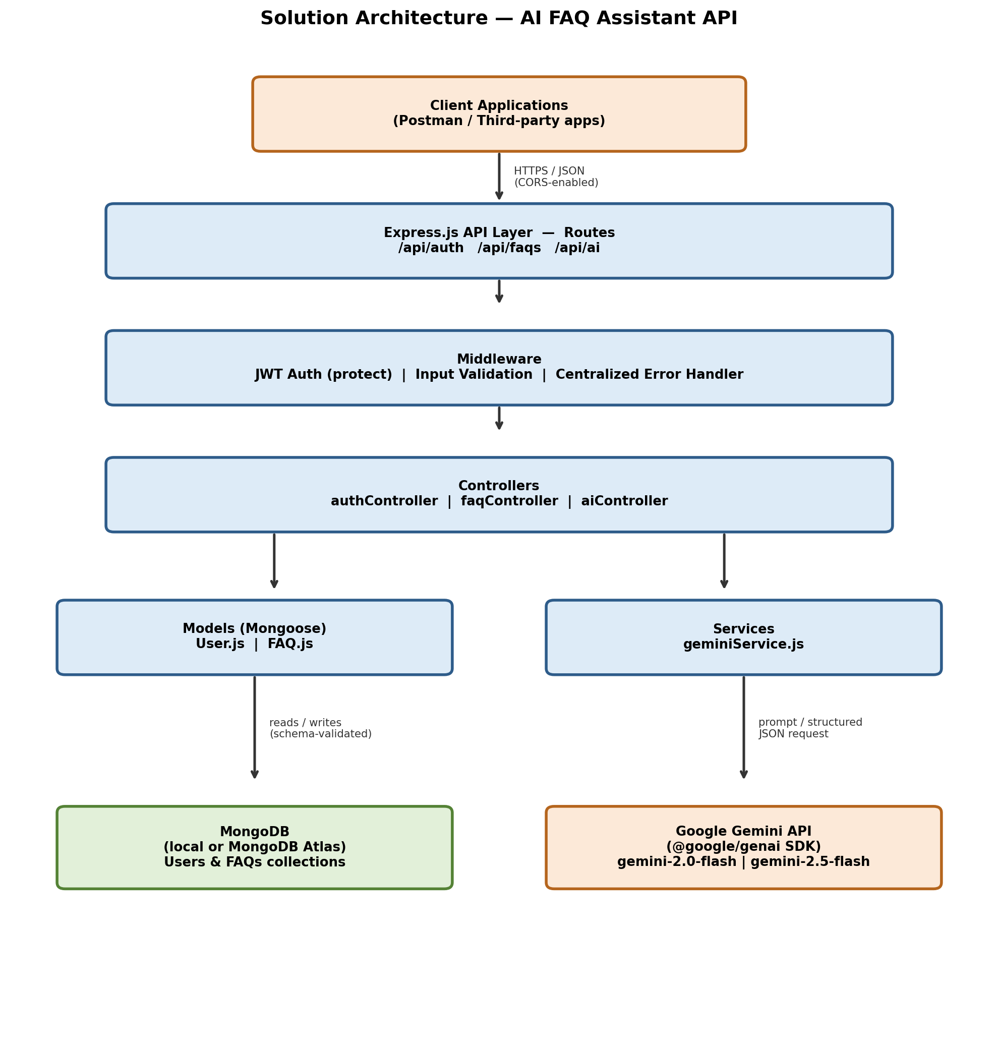
Figure 1: Solution Architecture Diagram

Table 1: Components & Technologies
S.No | Component | Description | Technology
1 | Application Logic — Authentication | Handles user registration, login, JWT issuance and verification, and profile retrieval. Passwords are hashed with bcrypt (10 salt rounds) before storage, and protected routes require a valid JWT on every request (stateless sessions). | Node.js, Express.js, jsonwebtoken (JWT), bcrypt (10 salt rounds)
2 | Application Logic — FAQ Management | Full CRUD for FAQ entries ({question, answer}) plus keyword search over FAQs using MongoDB regex matching (no external search engine). Editing and deleting an FAQ is restricted to the user who created it (creator-only authorization). | Express.js REST controllers, Mongoose ODM, MongoDB regex keyword search
3 | Application Logic — AI Service Bridge | A service layer that formats requests and responses between the controllers and the Gemini API, keeping the AI integration decoupled from the business logic (MVC separation). | Node.js service module using the @google/genai SDK
4 | Database | Schema-based User and FAQ collections with Mongoose schema validation. Runs against a local MongoDB instance or MongoDB Atlas, selected through the MONGO_URI connection string. | MongoDB accessed via Mongoose ODM
5 | External API | Google Gemini API used for two AI features: (1) generating direct answers to arbitrary user questions, and (2) generating structured {question, answer} FAQ pairs from a given topic using Gemini's structured JSON output feature. | @google/genai SDK — gemini-2.0-flash (direct answers) and gemini-2.5-flash (structured JSON output for FAQ generation)
6 | Machine Learning Model | The “AI” capability is a third-party hosted generative model used for answer and content generation. It is NOT a custom-trained or locally hosted model — the project contains no training pipeline, model files, or ML infrastructure; all intelligence is obtained through calls to the hosted Gemini API. | Google Gemini (gemini-2.0-flash / gemini-2.5-flash), consumed as a hosted API
7 | Infrastructure | Node.js/Express HTTP server. Local development via npm run dev; production-ready for deployment to any Node-compatible host (e.g., Render or Railway) with MongoDB Atlas as the managed database. Configuration is externalized through environment variables. | Node.js runtime, npm, dotenv (.env: PORT, MONGO_URI, JWT_SECRET, GEMINI_API_KEY)
8 | API Testing & Client | The project has no frontend; the API is tested and consumed exclusively through Postman. A pre-built Postman collection with automatic JWT token capture is included. | Postman (pre-built collection + environment with auto JWT capture)
9 | User Interface | Not applicable — backend/API-only project. | Not applicable
10 | File Storage | Not applicable — backend/API-only project. No file uploads, attachments, or cloud storage service are used. | Not applicable

Table 2: Application Characteristics
S.No | Characteristics | Description | Technology
1 | Open-Source Frameworks | The stack is built entirely on free, open-source technologies — the Express.js web framework and the Mongoose ODM run on the open-source Node.js runtime, alongside open-source community packages (jsonwebtoken, bcrypt, cors, dotenv). No proprietary or paid software is required to build or run the project; MongoDB offers a free local/community edition and a free Atlas tier. | Node.js, Express.js, Mongoose (open-source npm packages)
2 | Security Implementations | JWT-based stateless authentication (no server-side session storage); bcrypt password hashing with 10 salt rounds; input-validation middleware executed before controllers; a centralized Express error-handling middleware that uniformly covers validation errors, cast errors, and duplicate-key errors without leaking stack traces to clients; and a CORS policy (cors package) that allows any frontend or third-party client to consume the API. | jsonwebtoken, bcrypt (10 salt rounds), cors, Express middleware
3 | Scalable Architecture | The application is a stateless REST API organized with MVC separation (routes → controllers → services → models). Because no session state is kept in-process and every request carries its own JWT, instances can be horizontally scaled behind a load balancer, with all instances sharing the same MongoDB (Atlas) database via MONGO_URI. | Express.js (MVC), REST, Mongoose, MongoDB Atlas
4 | Availability | The database tier is hosted on MongoDB Atlas, which provides managed cloud hosting with replica sets and high uptime, keeping data available even if a node fails. At the application level, Node's unhandledRejection safety net catches fatal asynchronous errors and gracefully closes the server instead of leaving it running in an undefined state; combined with statelessness, multiple application instances can be run in parallel for redundancy. | MongoDB Atlas (replica sets), Node.js process-level error handling (unhandledRejection)
5 | Performance | All endpoints exchange lightweight JSON payloads over HTTP. FAQ lookup and keyword search run as indexed MongoDB queries (regex matching) for fast retrieval. AI generation is the main latency factor, since response time depends on the Gemini API; these calls are isolated in the AI service layer so they do not block or degrade the rest of the API. | Express.js (JSON responses), MongoDB indexes + regex queries, @google/genai

